Matthew Tran
Secret-Key Encryption: Modes, Padding, and Vulnerabilities
In this lab I practiced secret key encryption using OpenSSL and Python. I encrypted text and images with different modes like ECB and CBC. I saw how ECB leaves patterns visible while CBC hides them better. I also learned why padding is needed and why reusing an Initialization Vector is a security risk.
Tools Used
- OpenSSL
- Linux command-lines
- Python
- Ubuntu Linux Virtual Machine

Skills Learned
- Encrypting and decrypting files using OpenSSL
- Understanding block ciphers vs. stream cipher modes
- Visualizing data leakage in ECB mode
- Identifying when and why padding is required
- Inspecting PKCS padding at the byte level
- Understanding the role of IVs in CBC mode
- Exploiting IV reuse using XOR operations

Task 1) Encrypting Data Using Different Ciphers and Modes
- Opened the terminal inside my manually created virtual machine.
- Navigated to the directory containing article.txt using the cd command.
- Encrypted article.txt using AES-128-CBC with a manually specified key and IV using the command: openssl enc -aes-128-cbc -e -in article.txt -out article_aes_cbc.bin -K <key> -iv <iv>.
- Encrypted the same file using AES-128-CFB using: openssl enc -aes-128-cfb -e -in article.txt -out article_aes_cfb.bin -K <key> -iv <iv>.
- Encrypted the file again using Blowfish in CBC mode with openssl enc -bf-cbc -e -in article.txt -out article_bf_cbc.bin -K <key> -iv <iv>.
- Listed the encrypted output files using ls -l *.bin to confirm they were created.
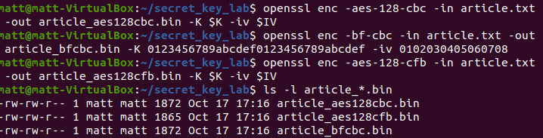
This task showed that encrypting the same plaintext using different encryption algorithms and modes produces completely different ciphertexts. It helped me understand how cipher choice and encryption mode directly impact how data is protected.
Task 2) Encrypting an Image Using ECB and CBC Modes

- Verified that pic_original.bmp existed in the working directory using ls.
- Encrypted the image using AES-128 in ECB mode with: openssl enc -aes-128-ecb -e -in pic_original.bmp -out encrypted_ecb.bmp -K <key>.
- Encrypted the same image using AES-128 in CBC mode with: openssl enc -aes-128-cbc -e -in pic_original.bmp -out encrypted_cbc.bmp -K <key> -iv <iv>.
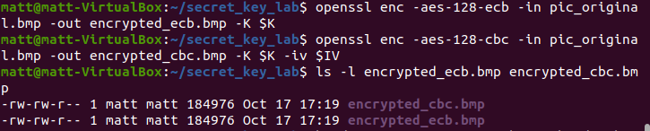
This task prepared the image files for comparison and demonstrated how ECB mode does not use an IV, while CBC mode relies on one to introduce randomness.
Task 3) Rebuilding Encrypted Images into Valid Bitmap Files
- Extracted the first 54 bytes (bitmap header) from the original image using: head -c 54 pic_original.bmp > header.bmp.
- Extracted the encrypted image data from the ECB-encrypted file using: tail -c +55 encrypted_ecb.bmp > ecb_data.bin.
- Combined the original header and encrypted ECB data using: cat header.bmp ecb_data.bin > encrypted_ecb_legitimate.bmp.
- Repeated the same process for the CBC-encrypted file to create encrypted_cbc_legitimate.bmp.
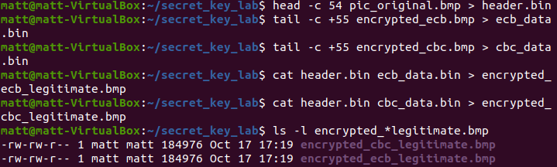
This step was necessary because bitmap files require a valid header to be displayed. By reusing the original header, I was able to view the encrypted image data correctly.
Task 4) Visual Comparison of ECB and CBC Encrypted Images
- Opened the reconstructed ECB image using: eog encrypted_ecb_legitimate.bmp.
- Opened the reconstructed CBC image using: eog encrypted_cbc_legitimate.bmp.

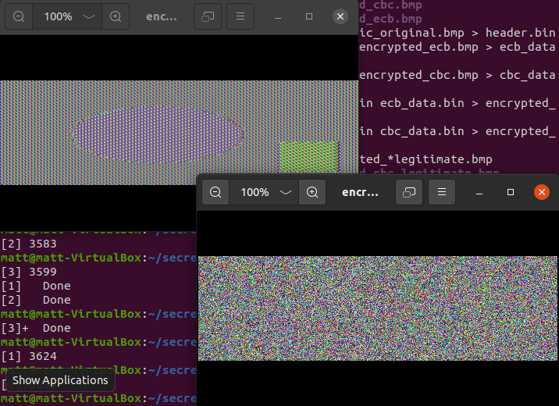
The ECB-encrypted image still revealed the structure and outline of the original image, while the CBC-encrypted image appeared as random noise. This showed that ECB mode leaks visual patterns and is insecure for structured data.

Task 5) Identifying Encryption Modes That Require Padding

- Used the commands show in the image below.
- Compared output file sizes using ls -l article_*.bin.

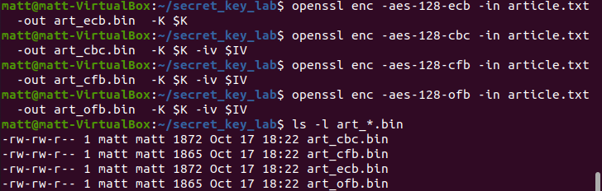
The ecb and cbc required padding because of the slightly larger output. They both had an output of 1872 whereas cfb and ofb had a size of 1865. The ecb and cbc files padded to make the plaintext a multiple of the AES block size (they are block ciphers). The cfb and ofb files are smaller because they are stream modes, that only need to encrypt exactly as many bytes as the input.
Task 6) Creating Files of Specific Sizes
- Created a 5-byte file using: echo -n "abcde" > f1.txt.
- Created a 10-byte file using: echo -n "abcdefghij" > f2.txt.
- Created a 16-byte file using: echo -n "abcdefghijklmnop" > f3.txt.
- Verified the file sizes using ls -l.

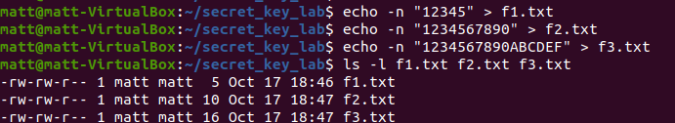
These files were used to clearly observe how padding behaves when encrypting data of different lengths relative to the AES block size.
Task 7) Inspecting PKCS Padding Behavior
- Encrypted all three files using AES-128-CBC.
- Decrypted each file using the -nopad option to preserve padding bytes.
- Used the hexdump -C command to view the decrypted output in hexadecimal format.

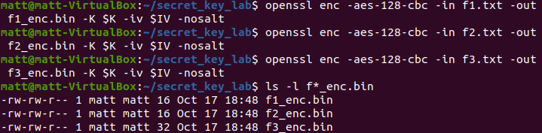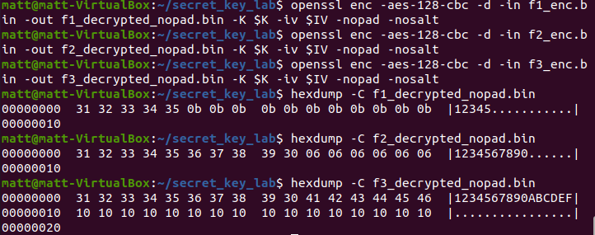
The results showed that files smaller than 16 bytes were padded to a full block, and a file that was exactly 16 bytes long received an additional full block of padding. This confirmed how PKCS padding works.
Task 8) Demonstrating the Importance of IV Uniqueness

- Encrypted article.txt using CBC mode with one IV.
- Encrypted the same file again using a different IV.
- Re-encrypted the file using the original IV.
- Compared the resulting ciphertext files.
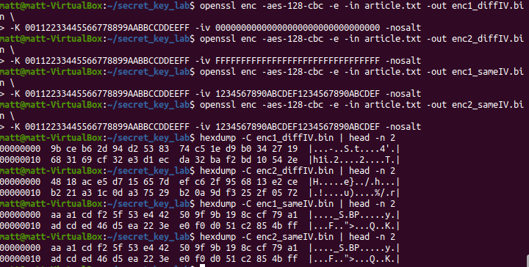
When the same IV was reused, the ciphertexts were identical. This demonstrated that IV reuse weakens security and must be avoided.
Task 9) Exploiting IV Reuse Using XOR
- Created and edited a Python script named iv_attack.py.
- Used XOR operations to compute T = P1 ⊕ C1 and recover the unknown plaintext using P2 = T ⊕ C2.
- Ran the script using python3 iv_attack.py.
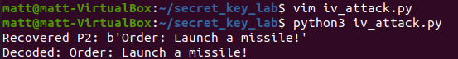
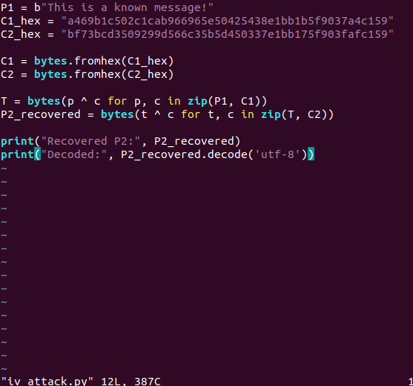
This task showed that reusing an IV allows an attacker to recover plaintext without knowing the encryption key, proving how dangerous improper IV usage can be.

